Uploading Echolocation Records
to the Bat Acoustic Monitoring Portal (BatAMP)
User’s Guide Version 3.0
December 2014

- Join Databasin… batamp.databasin.org and “Become a Member” (see graphic below).
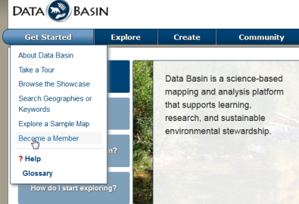

- Become a member of the BatAMP community:
http://batamp.databasin.org/groups/59d81a3951fd4915909efacbe2317efb
(or search for BatAMP within Databasin or Google)

- Obtain authorization to upload data (this happens on our end and behind the scenes… I will let you know when you are approved. Meanwhile move on to Step 4).

- Prepare an EXCEL or comma-delimited file that follows the following convention. In short, it should present the number of files recorded and identified to species (4 letter code), species group (e.g., Q40k, LACITABR, HiF), or simply number of bats. Common species groups are defined in the Appendix. Night is defined as the night on which recording started. The only required columns are Site ID, Det ID, and Night. Each EXCEL file should only contain data from a single year and site. Rows for nights when the detector malfunctioned or was not operational should be deleted.
This column must be labeled “Det ID” (i.e., cannot be labeled “Detector ID” etc.).

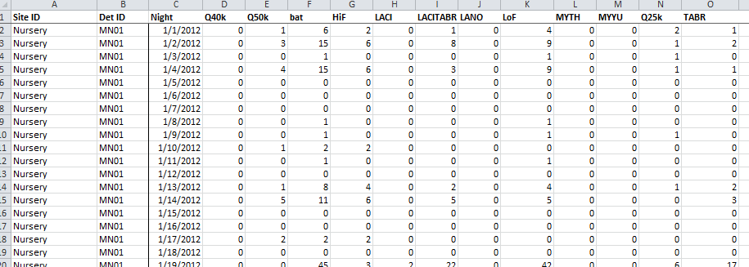
- Assemble for ready-access, the metadata associated with the dataset including
  - Spatial coordinates (Lat/Long or UTM (including geodetic datum and zone)
  - Type of detector
  - Type of weatherproofing
  - Type of call analysis programs used
  - Additional information on how/where detector was placed and the reasons for placing it there

- Import the dataset
Screen 1
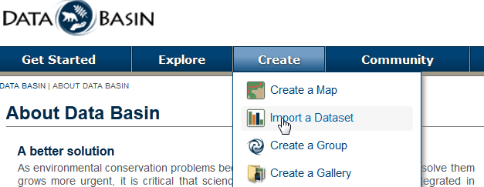

Screen 2
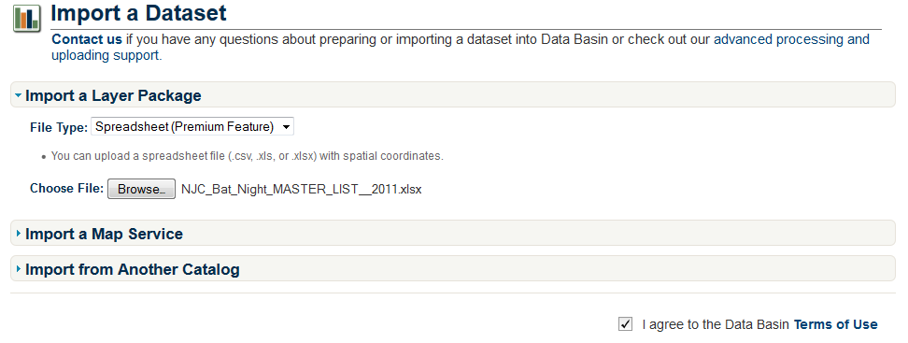
Select Spreadsheet (this is a “premium feature” associated with BatAMP. There is no cost or special sign-ups.
Agree to terms and “submit”
Browse to select your EXCEL (or other) spreadsheet

- Select a Dataset Definition for the year data were recorded
Select the dataset definition for the year files were recorded.
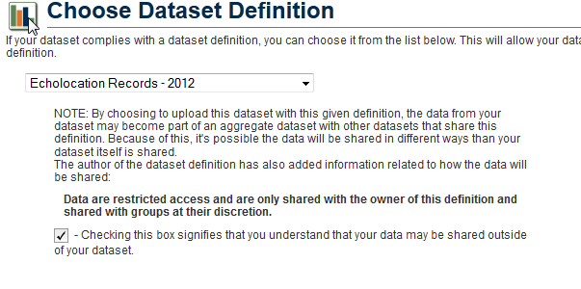
In order to upload, you must check this box. This does not necessarily mean that your data will be “publicly”-available. For more information on keeping your data private, please contact Ted Weller.

- Provide metadata for the dataset
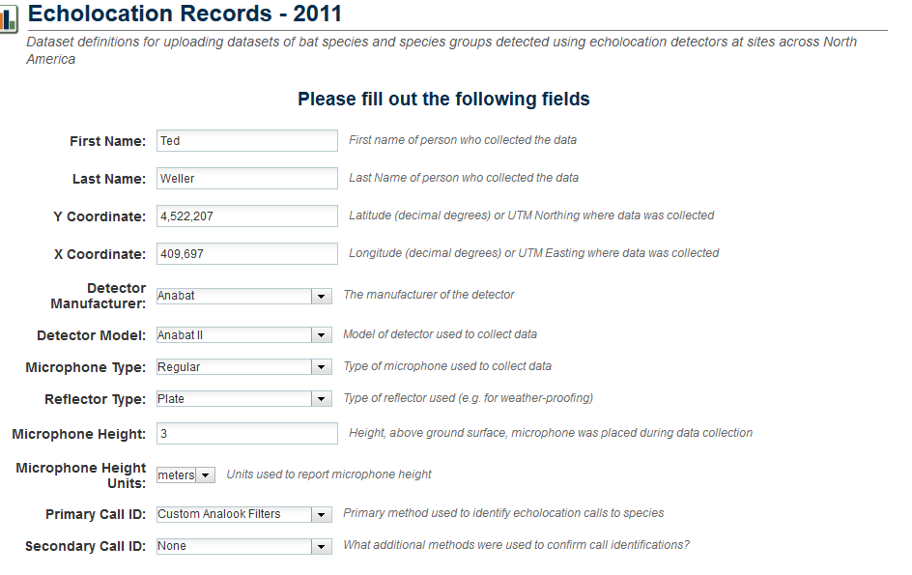
Specifications of detector used and ID process should be selected from dropdown menus.
In this case, UTM Northing and Easting were selected. Lat/Long in decimal degrees are also acceptable.
NOTE: For 2 detectors the same X and Y coordinates (e.g. 2 detectors on the same meteorological tower), one strategy is to offset the detectors by adding a specified amount to the Y coordinate, to serve as a surrogate for height. This should be included in the detector description.

- Provide Spatial Projection information (note: the WGS-84 geodetic system applies to both lat/long and UTM coordinates …choose carefully)

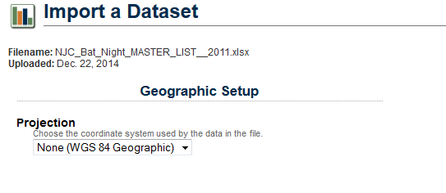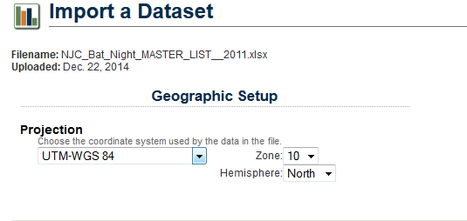
Select None (WGS 84 Geographic) if Latitude/Longitude (decimal deg) are used.
Select appropriate coordinate system if UTM coordinates are used.. and select UTM Zone
OR
- Provide descriptive information about the dataset. Consider including a description of the detector setting (e.g., near a pond, on a roof), the purpose of the detector, the goal of the larger project, species known from the area etc.
Provide an informative title for the dataset (in this case to make it more intuitive than original).

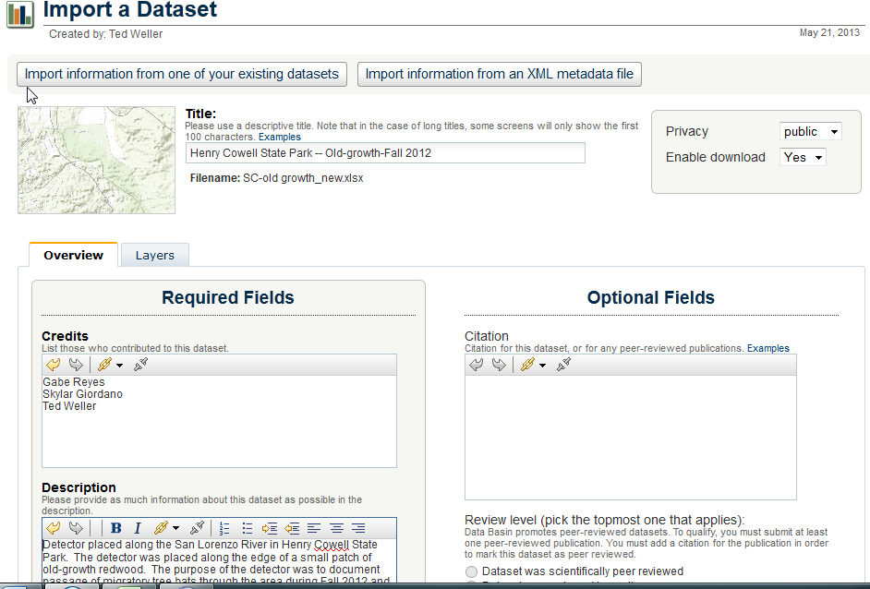
We encourage submission of public datasets. If you desire a private dataset, please contact Ted Weller for guidance and instructions.

Add tags and contact person information (these can be pulled from your DataBasin profile)
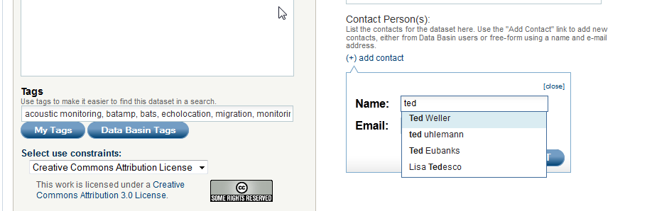

- An error message, like the following, usually means that your dataset contains a column that is not part of the dataset definition (e.g., it contains more than Site ID, Det ID, Night, and species codes OR it contains a column heading (e.g., species group) not in the data definition).
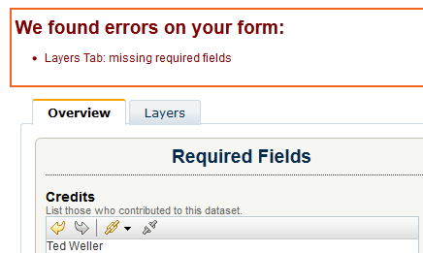
  - It is fine to upload additional columns of data for your own purposes. You will just need to provide a definition for each of these terms by clicking on and completing the “Layers” tab.

For example, this dataset contained a species group (LACITABR) that was not in the 2011 dataset definition. The system recognizes this and asks the user to self-define this variable (In this case it was defined as “Number of files identified as either LACI or TABR on a given night”).

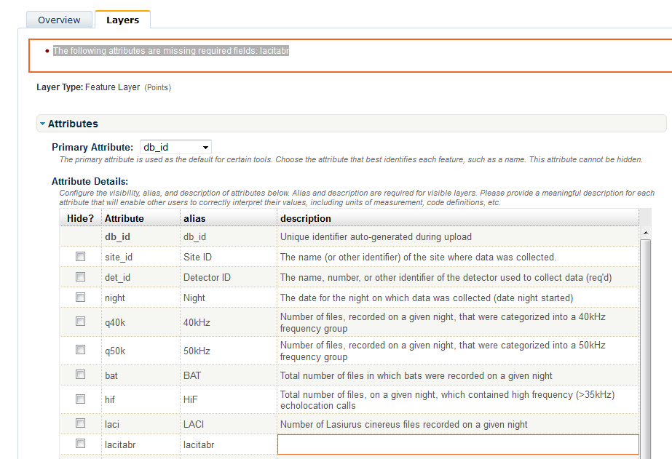
- At the bottom of the “Layers” Tab there is an opportunity to style your dataset according to your preferences. Generally one will want to style according to the species or species group of greatest interest. Under “method” there options for equal interval, natural breaks, and manual. In this case, we styled on LACI (hoary bat) and the “natural breaks” option revealed that the maximum value for was 9 recordings. This information was used in manual mode to suggest 4 classes of symbols to represent hoary bat detections.
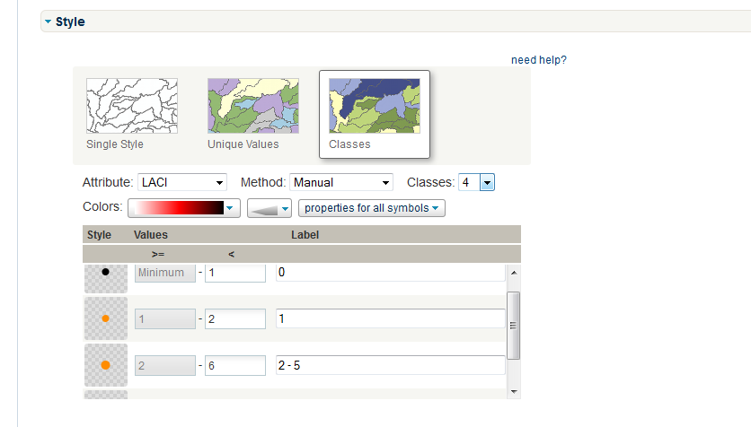
Note that “label” does not precisely match “values”. For instance the value ≥1 and < 2 must be manually labeled as “1”

- After a successful import, your dataset can be found under the “My Workspace” tab.
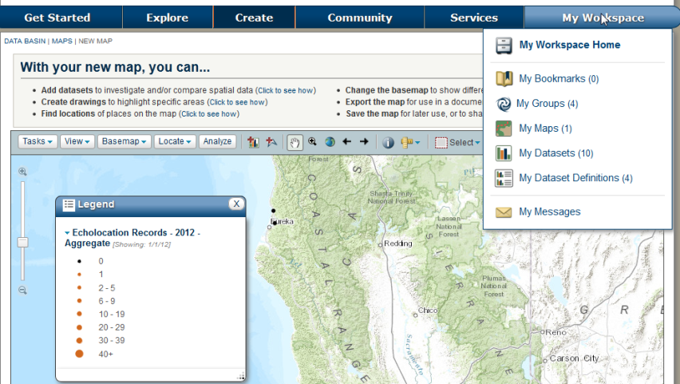

- After importing datasets you may wish to change the style to display particular information in a particular way (e.g. number of detections by a species). This can be done on individual datasets or the aggregate datasets and saved as a map. There are 2 options:
- Open a dataset>Manage>Edit Dataset>
  - On the Layers Tab, toward the bottom select the attribute you wish to style

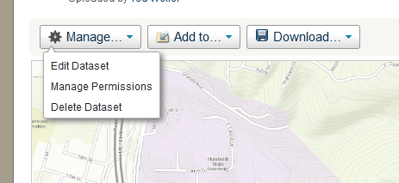

- OR use slide out the Layers tab (from left) and select attribute on which you want to style

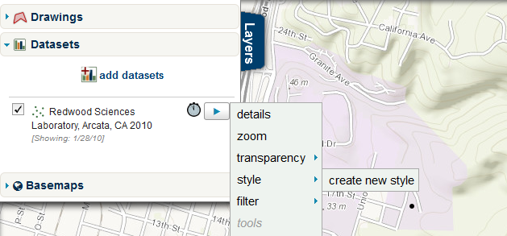

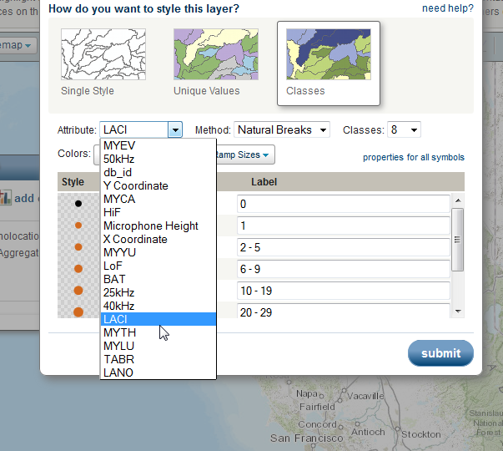

For maximum flexibility, select method = manual and specify number of classes; you may wish to use natural breaks, symbols of all one size or color etc. Here is your chance to be creative and display your data however you like.
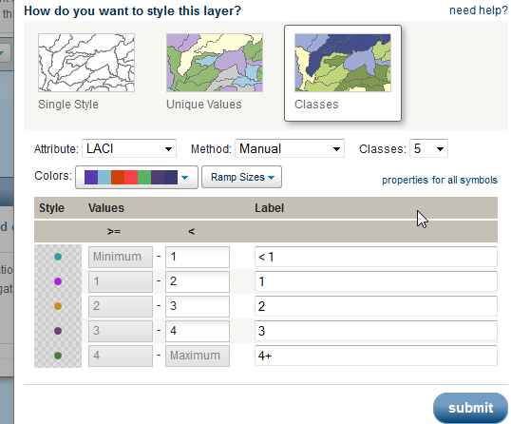

- Save the new style. Your only choice will be to save it as a MAP. Attribute the map as descriptively as possible and then submit. You will now have an interactive map, using your styling, which can be found under the My Workspace tab.
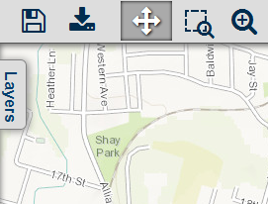
Use the Save Icon

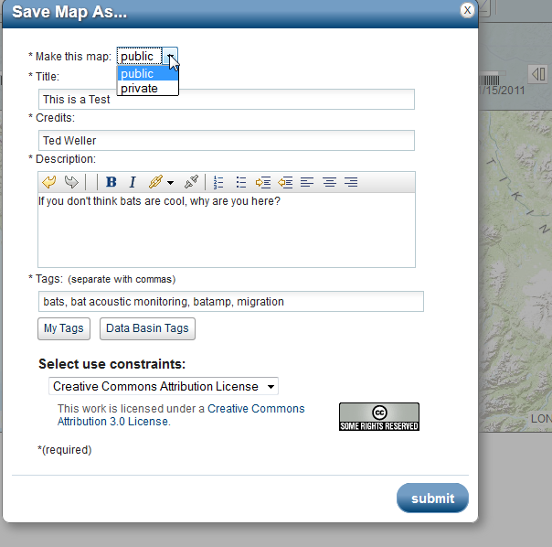

- Note that style changes only apply to that map and dataset. If you allow your data to be visualized publicly it will be contribute to the “aggregate dataset” for that particular year. The styling of your dataset within the aggregate will conform to the style specifications of the aggregate dataset.
Appendix – Species group definitions used in dataset definitions.
Code | Description | Years Included
HiF | File contains calls that are > 35kHz | 2006-Present
LoF | File contains calls that are <35kHz | 2006-Present
Q40k | Calls categorized into a 40kHz group | 2006-Present
Q50k | Calls categorized into a 50kHz group | 2006-Present
Q25k | Calls categorized into 25kHz group (generally 24-31kHz) | 2006-Present
Bat | Total number of files containing bats | 2006-Present
LACITABR | Calls identified as either LACI or TABR | 2006-2009, 2014-Present
MYCAMYYU | Calls identified as either MYCA or MYYU | 2006-2009, 2014-Present

